**S-98 – PART C**

**LEVEL 3 INTEROPERABILITY**

Page intentionally left blank

Contents

1 Introduction 6

1.1 How to read this Part 6

2 Specification Scope for Part A 6

3 Data Content and structure 7

3.1 Application Schema 7

3.1.1 Overview of application schema 7

3.1.2 Operations in Pre-Defined Combinations 10

3.1.3 Enhanced selection of feature instances 10

3.1.4 Interoperability levels 10

3.1.5 Hybridization rules 11

3.1.6 Hybrid feature and portrayal catalogues 11

3.1.7 Progression of interoperability levels 11

3.2 Interoperability Catalogue 12

3.2.1 Conceptual Types for Level 3 Interoperability 12

3.2.2 Use of S-100 types 14

3.3 UML model documentation 14

4 Level-specific data quality considerations 16

4.1 Quality of displayed data 16

4.2 Quality of interoperability catalogues 17

4.2.1 Test methods 17

4.2.2 Data quality testing 18

5 Level-specific Guidance on Making Product Specifications Interoperable 18

5.1 Duplicated features 18

5.1.1 Duplicated features same model 18

5.1.2 Duplicated features, different models 19

5.1.3 Duplicate feature domains 19

5.2 Geometry 19

5.2.1 Combined geometry 19

5.2.2 Spatial discrepancy, unrelated to scaled or cartographic smoothing 19

5.2.3 Spatial discrepancies, related to scale or cartographic smoothing 19

5.3 Display of text 19

5.4 Skin-of-the-earth feature operations 19

5.4.1 Skin of the earth feature replacement 19

5.4.2 Skin-of-the earth feature adjusting 20

5.5 Blended feature concepts 20

5.6 Hierarchy of data 20

5.6.1 Hierarchy by stacking of display planes 20

5.6.2 Predefined combinations 21

5.7 New datasets 21

5.8 Dataset scales, loading, and unloading 21

5.9 Metadata 21

5.10 Meta-features 21

5.11 Quality considerations 21

6 Portrayal 21

6.1 Display of significant features 22

6.2 Display of significant features - switching to original 22

6.3 Portrayal distinguishability - colour set-asides 22

6.4 Day/night/dusk modes 22

6.5 Impacts on viewing groups 22

6.6 Impacts on Portrayal Catalogues 22

6.7 Meta-features 22

6.8 Display of text 22

6.9 Skin-of-the-earth operations and portrayal 22

6.9.1 Skin-of-the-earth feature replacement and portrayal 22

6.9.2 Skin-of-the-earth feature adjusting and portrayal 23

6.10 Blended portrayals 23

6.11 Hierarchy of data 23

6.11.1 Interacting gridded information 23

6.12 Pick reports 23

7 Processing Model 23

8 Normative Implementation Guidance 26

9 Feature Catalogue 26

10 Portrayal Catalogue 26

Page intentionally left blank

# Introduction

S-98 Part A contains information that applies to interoperability catalogues which use interoperability rules and operations of at most Level 1 interoperability.

Interoperability catalogues conforming to this Part must comply with both the following components of S-98:

1. S-98 Main Specification, which describes requirements applying to all S-98 interoperability catalogues and S-98 exchange sets;
2. S-98 Part A (this Part), which defines the subset of the interoperability model and catalogue encoding that are specific to Level 1 interoperability.

The hypothetical processing model for implementations is described in general terms in the “S-98 - Main” document and elaborated in clause 7 of this Part.

Level 3 interoperability includes the following capabilities:

* Level 1 interoperability, in which feature types from different products, including S-101, are interleaved as specified by display plane and drawing priority information contained in the Interoperability Catalogue.
* Level 2 type suppression functionality, which allows suppression of all features of a specified feature type in a specified product, with another feature type from a different product being displayed instead. Filtering by attribute values and geometry type is also possible.
* Level 2 constructs allowing catalogues to partition interoperability rules and operations according to specified combinations of data products (“predefined combinations”). The rules and operations in each partition are applied only when the corresponding data products are part of the display.
* Additional interoperability functionality introduced in Level 3 for allowing suppression of selected feature instances and combination or conversion of feature types from input products into different feature types for display and alert processing purposes. In Level 3, combination/conversion operations are limited to thematic attributes.

The output of interoperability processing is either the original feature data (processing option 1) or drawing instructions (processing option 2), accompanied by display plane and drawing priority information, which is passed through to the portrayal processor. Clause 7 elaborates on these options.

## How to read this Part

Clause 2 of this Part contains scope identification information corresponding to the contents of this Part, which applies specifically to Interoperability catalogues designated as Level 3.

For Clauses 3–10, the content of the clause or sub-clause extends or elaborates on the content under the same or similar clause head or sub-head in S-98 – Main.

The numbering of Clauses 3-10 may differ from that of corresponding clauses in S-98 – Main, because for some there is no additional level-specific information needed. If a clause or sub-clause in S-98 – Main has no corresponding clause or sub-clause in this Part, there is no level-specific information on that topic.

# Specification Scope for Part A

S-98 Part A describes the portions of S-98 which correspond to the following scope defined in S-98 – Main (Clause 2):

**Scope Identification:** S98L3

**Level**: MD_ScopeCode – 13

**Level Name**: Interoperability Level 3

**Description**: Instance-based selectivity and feature hybridization; type selectivity; interleaving

**Extent**: EX_Extent.description = “worldwide”; EX_GeographicBoundingBox = [-180, +180, -90, +90]

# Data Content and structure

## Application Schema

### Overview of application schema

The application schema for Interoperability Level 3 is depicted in Figure 3.1 below. This application schema is a subset of the full application schema in S-100 Part 16. It consists of the following components:

1. Catalogue header information.
2. Display plane ordering information.
3. Display planes content in the form of either features or drawing instructions.
4. Specification of rules indicating which feature layers to suppress.
5. Specification of data product combinations and method of referencing collections of interoperability rules and operations to specific combinations.
6. Specification of rules indicating which feature instances to suppress.
7. Rules for combining feature data into new features based on thematic attributes.
8. Operations involving only thematic attributes, for combining selected instances of feature types from different data products, or conversion of feature data into new feature data.
9. Feature and Portrayal Catalogues for the new features generated according to the abovementioned combination or conversion operations.

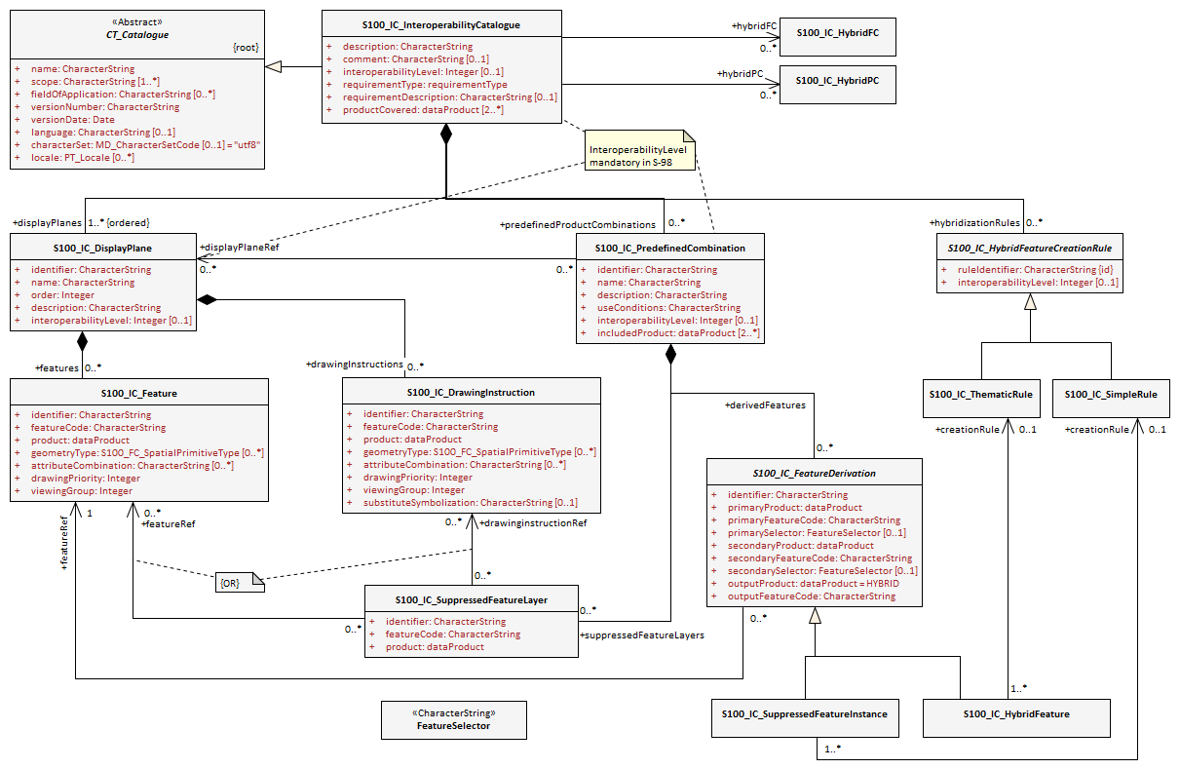

*Figure 3‑1 – Level 3 interoperability catalogue*

Page intentionally left blank

### Operations in Pre-Defined Combinations

Level 3 allows predefined combinations, whereby the scope of specified interoperability operations can be restricted so the operations are executed only when a specified set of data products is active on the user display. Display plane and feature ordering (Level 1 operations) can be thus restricted by associating a specific set of products (listed in **S100_IC_PredefinedCombination** elements) to **S100_IC_DisplayPlane** elements.

Level 3 interoperability also allows replacement of a feature layer from one product by a feature layer from another product. These layers are specified by **S100_IC_SuppressedFeatureLayer** elements. Replacement operations are restricted to occur only when specific combinations of data products are present on the user display because the **S100_IC_SuppressedFeatureLayer** elements in interoperability catalogues are always contained within **S100_IC_PredefinedCombination** elements.

Level 3 also allows more complex operations, including conversion of input feature instances into new features (hybridization) as described by **S100_IC_HybridFeature** elements. The replacement and hybridization rules are described in Clause 3.1.5. The additional operations allowed in Level 3 are:

1. Operations on selected instances of a feature type.
2. Conversion of input feature data into new feature data involving only thematic attributes.

### Enhanced selection of feature instances

**S100_IC_SuppressedFeatureInstance** and **S100_IC_HybridFeature** elements specify the feature types on which they operate by indicating the product and feature types of two products. Selection of feature instances is done by evaluating a filter expression (type **FeatureSelector**, a string expression conforming to the specified [TBD] format) with the feature instance as input parameter. A **FeatureSelector** is a more expressive form of the attribute-value combination filter described in Clause 4.3 (S-98 – Main) that can include spatial operations and more complex expressions on thematic attributes.

[NOTE: If a scripting language for selection is developed it will belong in this level – the TBD in the previous sentence would be the specification of the scripting language, and equally importantly, their call/function signatures and restrictions on what the scripts are allowed to do.]

For Level 3 interoperability, spatial equality is an implied criterion in determining each input instance set of feature instances to be converted to new feature data uses spatial equality as an implicit criterion for set membership; that is, only coincident instances (to a system-determined tolerance) are combined, and the geometry of the output is the same as the geometry of any instance in the input set.

### Interoperability levels

The *interoperabilityLevel* attribute in **S100_IC_InteroperabilityCatalogue** specifies the highest level of interoperability implemented in that XML interoperability catalogue file. The *interoperabilityLevel* attribute in **S100_IC_DisplayPlane** specifies the level to which that display plane pertains.

The *interoperabilityLevel* attribute in each **S100_IC_PredefinedCombination** element specifies the highest level of interoperability operations that are encoded in the element. **S100_IC_PredefinedCombination** elements are permitted to also include operations of a lower level of interoperability.

The *interoperabilityLevel* attribute in **S100_HybridFeatureCreationRule** specifies the interoperability level to which that rule applies. In Level 3 catalogues the value must be 3.

### Hybridization rules

Hybridization rules define how a set of feature instances is combined to create a hybrid feature type. In the simplest form of hybridization, the hybrid feature would bind all the attributes of the input types to a single output feature type (this assumes that there are no collisions[1] between the thematic attributes of the input types.) More complex hybridization rules can handle collisions, for example by defining a preference order for colliding attributes, including all the values if the input types bind the same enumerated attribute, or adding uncertainty metadata if numeric attribute values are different.

The hybridization rules require two feature instances as input and produce a single feature instance as output. The formal specification and rule language for hybridization will be described in a subsequent version of this Specification.

#### Simple hybridization rule

Simple rules treat thematic attributes uniformly, for example by binding the attributes of both primary and secondary input instances to the output instance, or preferring the attribute bindings of the primary instance to those of the secondary instance in case of a difference in the values of common attributes. Location/extent spatial attributes of all input instances must be spatially equal and are passed through unchanged.

#### Thematic hybridization rule

Thematic rules treat thematic attributes on an individual basis, for example, use specified attributes from the primary input instance and specified attributes from the secondary input instance. Combination operations on attribute values may be specified (for example, OutputFeature.depthValue = maximum(ProductA.FeatureX.depthValue, ProductB.FeatureY.depthValue). Location/extent spatial attributes of all input instances must be spatially equal (as defined in IHO S-58) and are passed through unchanged.

### Hybrid feature and portrayal catalogues

Hybrid Feature and Portrayal Catalogues are physically separate files from the main Interoperability Catalogue, but the main Catalogue links to them by encoding the names of the hybrid catalogue files which are used by the feature creation rules defined in it. The hybrid Feature and Portrayal Catalogues conform to the structures required by S-100 Parts 5 and 9 respectively.

### Progression of interoperability levels

Figure 3.2 below shows the components of the model subset used by this level compared to lower levels.

Level 2 adds predefined combinations and feature suppression elements to Level 1.

Level 3 adds elements related to thematic hybridization to Level 2 functionality.

Interoperability catalogues at any level can also use lower-level functionality.

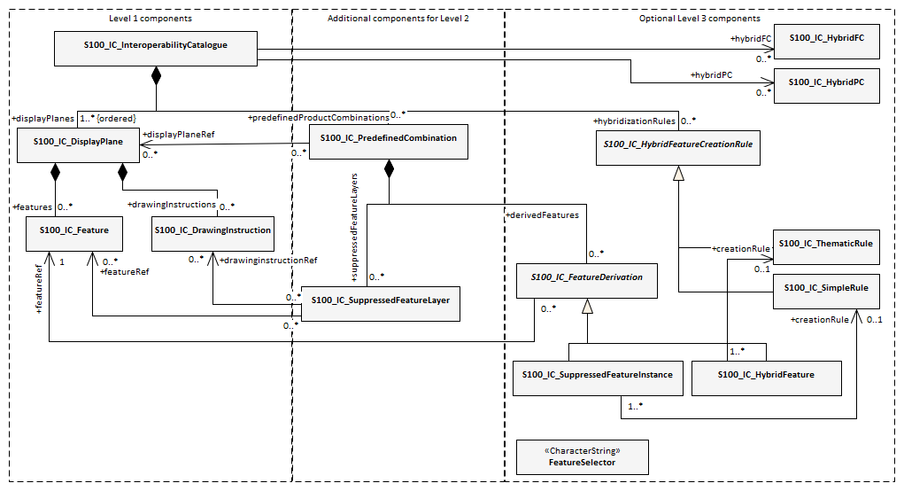

*Figure 3‑2 - Progressive use of Interoperability Catalogue model*

## Interoperability Catalogue

### Conceptual Types for Level 3 Interoperability

The following clauses summarize the conceptual elements used in Level 3 Interoperability Catalogues. Details about these conceptual types are provided in S-100 Part 16.

#### Display Plane (S100_IC_DisplayPlane)

A display plane element in the interoperability catalogue acts as a container for display information for specified feature classes, which enables the interleaving of feature layers during portrayal by indicating the display plane, priority, and drawing order of the features assigned to a display plane.

A feature type may be referenced in more than one **S100_IC_DisplayPlane**, but the entries in different display planes must be distinguished by different attribute-value combinations or spatial primitives so that the actual instances of features are partitioned unambiguously between different display planes.

The portrayal of feature types not mentioned in any **S100_IC_DisplayPlane** component is undefined until ordinary portrayal processing takes place.

#### Feature type display information (S100_IC_Feature)

The **S100_IC_Feature** element describes the display parameters for all features of a specific feature type in a specific product and thereby determines the order of drawing the feature type relative to other feature types in the same display plane. It also specifies the viewing group to which the feature is assigned. Its applicability can be optionally restricted to a subset of instances of the feature type by additional attributes that specify the type of spatial primitive and indicate specific values of thematic attributes.

#### Feature layer (S100_IC_SuppressedFeatureLayer)

Each instance of this element identifies a feature type in a specific data product which is supposed to be suppressed in the presence of another specified feature type from another product.

#### Drawing instruction (S100_IC_DrawingInstruction)

Drawing instructions in the Interoperability Catalogue play a similar role to feature type display information (**S100_IC_FeatureType**) but with drawing instructions instead of feature objects. The **S100_IC_DrawingInstruction** element in Interoperability Catalogues is similar in operation to the layering and priority aspects of the **DrawingInstruction** element in Portrayal Catalogues (see S-100 Part 9 - Portrayal). Where there is a conflict with a Portrayal Catalogue drawing instruction, the drawing instruction in the Interoperability Catalogue supersedes the drawing instruction in the Portrayal Catalogue.

The **S100_IC_DrawingInstruction** element contains an additional attribute that allows substitution of symbolization instructions generated by portrayal processing.

##### Comparison and use of S100_IC_Feature and S100_IC_DrawingInstruction

**S100_IC_Feature** and **S100_IC_DrawingInstruction** elements in Interoperability Catalogues operate in essentially the same way as far as assignment of drawing order, priority, and display planes is concerned. They differ in that **S100_IC_DrawingInstruction** provides an optional attribute to substitute the symbolization elements of the drawing instruction.

**S100_IC_Feature** should be used for Interoperability Catalogues that are designed for systems where interoperability processing precedes the generation of drawing instructions.

**S100_IC_DrawingInstruction** should be used for Interoperability Catalogues that are designed for systems where interoperability processing precedes the generation of drawing instructions. It should also be used in all catalogues where substitution of symbolization is necessary.

#### Predefined combination (S100_IC_PredefinedCombination)

A predefined combination element defines a collection of data products for which a common set of interoperability operations have been defined in the Interoperability Catalogue. Instances of predefined combinations are also characterized by interoperability level, which allows the encoding of different sets of operations depending on how tightly integrated the user desires the products to be on the resultant display.

The *interoperabilityLevel* attribute in each **S100_IC_PredefinedCombination** element specifies the highest level of interoperability operations that are encoded in the element. **S100_IC_PredefinedCombination** elements with a specified level attribute are permitted to also include operations of a lower level of interoperability.

Predefined combinations can be linked to **S100_IC_DisplayPlane** elements by means of references in the **S100_IC_PredefinedCombination** elements.

#### Suppressed feature Instance (S100_SuppressedFeatureInstance)

This element allows interoperability catalogues to indicate when specific feature instances in a data product mut be suppressed by specific feature instances in another product. Its functionality is similar to S100_SuppressedFeatureLayer except that it can use somewhat more expressive selection/replacement rules (by virtue of its dependency on **S100_SimpleRule**) and it applies to feature instances instead of feature types or subsets of feature types.

#### Feature hybridization (S100_HybridFeature)

This element allows selected feature types or instances to be combined into a new feature for display purposes.

#### Feature creation or replacement rule (S100_SimpleRule, S100_ThematicRule)

Feature creation and replacement is advanced functionality whose implementation is not required for this version of the Interoperability Catalogue.

Feature creation and replacement rules create new feature types by combining characteristics of specified feature types from the input data products. A feature creation/replacement rule basically transforms a collection of feature instances in the input stream into one or more different feature instances in the output stream. The created feature differs from all the input features, for example by adding properties of one feature to properties of another feature.

### Use of S-100 types

The S-100 types used by S-98 Level 3 interoperability catalogues are described in the S-98 – Main component of this Specification. For Level 3 interoperability catalogues, the following additional information applies.

* Interoperability Catalogues of Level 3 do not use feature and information associations in feature filters defined by *attributeCombination* attributes in **S100_S100_IC_Feature** or **S100_IC_DrawingInstruction** elements. This is the same as the Level 1 and 2 functionality for these elements.
* Interoperability Catalogues of Level 3 are allowed to use feature and information associations in feature selector expressions encoded in the *primarySelector* and *secondarySelector* attributes of **S100__IC_DerivedFeature** or in **S100_SimpleRule** or **S100_ThematicRule** elements.

## UML model documentation

The UML model documentation is provided in S-100 Part 16. This clause documents details specific to the use of the UML model for the interoperability level described in this Part of S-98.

Only the model elements used in this level (and included in the level’s application schema) are listed. The constraints and considerations listed in the UML documentation tables in S-100 Part 16 apply. Any S-98 general or level-specific considerations are described under the element name in the list below.

1. **S100_IC_DisplayPlane**: No level-specific constraints or notes

**Attribute** *interoperabilityLevel*: Mandatory. The only values allowed for Level 3 interoperability catalogues are 1, 2, and 3.

1. **S100_IC_DrawingInstruction**:

NOTE for implementers: Even if the Presentation schema in S-100 Part 9 is used, implementers may need to provide specific code to validate the content of the *substituteSymbolization* attribute instead of depending on normal XML schema validation. The content of this attribute is not prescribed by this specification and may be a fragment of XML, or interpretable code or rules, etc., in a non-XML syntax. It may be enclosed in a <![CDATA[ … ]]> section so that XML validators treat it as character data instead of XML.

1. **S100_IC_Feature**: No level-specific constraints or notes
2. **S100_IC_InteroperabilityCatalogue**:

**Attribute** *productCovered*: Must use values defined in the dictionary identified by MRN: urn:mrn:iho:prod:s98:1:0:0:products

**Attribute** *interoperabilityLevel*: Mandatory in S-98 catalogues at all levels. The only value allowed for Level 3 interoperability catalogues is 3.

**Role hybridFC**: Required if and only if there are any feature hybridization rules in the catalogue.

**Role hybridPC**: Required if and only if there are any feature hybridization rules in the catalogue.

**Role hybridizationRules**: Required if and only if there are any instances of S100_IC_SimpleRule, S100_IC_ThematicRule, or S100_IC_CompleteRule in the catalogue.

1. **S100_IC_PredefinedCombination**:

**Attribute** *interoperabilityLevel*: Mandatory in S-98 interoperability catalogue; allowed values: 1, 2, 3.

1. **S100_IC_SuppressedFeatureLayer**: No level-specific constraints or notes
2. **Codelist dataProduct**: No level-specific constraints or notes. The data type for all levels is described below.

Codelist Type: closed dictionary

MRN: urn:mrn:iho:prod:s98:1:0:0:products

1. **Codelist requirementType**: No level-specific constraints or notes.

For all interoperability levels, the following subset of the standard values listed in S-100 Part 16 are permitted to be used in S-98 interoperability catalogues:

Table 3‑1 - Allowed values for requirementType

| **Value** | **Description** | **Code** |
| --- | --- | --- |
| IHO | Original IHO Interoperability Catalogue | 1 |
| OEM | Prepared according to requirements specified by OEM or systems integrator | 2 |
| national | Prepared according to requirements specified by a national government, group of national governments (for example the European Union), or governmental agency such as a national shipping authority or the Coast Guard. | 3 |
| local | Prepared according to requirements specified by a sub-national governmental authority such as a state, province, or county | 4 |
| port | Prepared according to requirements specified by a harbormaster's office or port authority | 5 |
| company | Prepared according to requirements specified by the owner, charterer, or operator | 6 |
| pilot | Prepared according to requirements specified by a pilot | 7 |
| master | Prepared according to requirements specified by the vessel’s master | 8 |

Extra values (“other: ...”) as defined in S-100 § 3-6.7 are also permitted.

1. **S100_IC_FeatureDerivation**:

The resulting derived feature does not need to have any hybrid characteristics, that is, one restricted area replaced with another restricted area will use regular PC/FC of the primary product. However if the result feature needs to be supported by any custom FC or PC elements they must be defined under hybrid FC and hybrid PC accordingly.

A rule for creating the feature must be described in the rules section of the interoperability catalogue.

**Attribute** *primarySelector*: If omitted, all instances of the type are included.

In L3 processing, may contain only thematic attributes and the primary and secondary instance geometries must be spatially equal.

L3 Example: CATICE = 5

**Attribute** *secondarySelector*: If omitted, all instances of the type are included.

In L3 processing, may contain only thematic attributes and the primary and secondary instance geometries must be spatially equal.

L3 Example: CATICE = 5

NOTE: **S100_IC_FeatureDerivation** is an abstract super-class for different types of feature hybridization operations.

1. **S100_IC_HybridFC**: No level-specific constraints or notes.
2. **S100_IC_HybridFeature**: No level-specific constraints or notes.
3. **S100_IC_HybridFeatureCreationRule**: No level-specific constraints or notes.

**Attribute** *interoperabilityLevel*: Mandatory in S-98.

NOTE 1: **S100_IC_HybridFeatureCreationRule** is an abstract super-class for different types of hybridization rules. This functionality needs to be worked out but OGC Filter seems to be the ideal option for defining data filtering logic.

NOTE 2: Overall, the output from execution of **S100_IC_HybridFeatureCreationRule** is a set of hybrid features for which predefined FC, PC and display plane definitions already exist so such feature will be suitable for passing to the portrayal engine for processing just like any other S-100 features.

1. **S100_HybridPC**: No level-specific constraints or notes.
2. **S100_IC_PredefinedCombination**

**Role** *derivedFeatures*: Required if and only if there are any instances of **S100_SuppressedFeatureInstance** or subclasses of the abstract class **S100_IC_HybridFeature** in the catalogue.

1. **S100_IC_SimpleRule**: No level-specific constraints or notes.
2. **S100_IC_SuppressedFeatureInstance**: No level-specific constraints or notes.
3. **S100_IC_ThematicRule**: No level-specific constraints or notes.
4. **FeatureSelector**: No level-specific constraints or notes.

# Level-specific data quality considerations

## Quality of displayed data

There are no level-specific extensions to Clause 6.1 of the “S98 – Main” document.

Clause 5.10 provides guidance for maintaining data quality for level-specific rules and operations.

## Quality of interoperability catalogues

The quality measures recommended in S-97 (Part C) which are applicable to Level 3 S-98 interoperability catalogues are those listed in Table 6-1 of the “S-98 – Main” document plus those listed in Table 4‑1 below.

*Table 4‑1 - Quality elements for Level 3 S-98 interoperability catalogues*

| **No.** | **Data quality element and sub element** | **Definition** | **DQ measure / description** | **Evaluation scope****[2] for IC** | **Evaluation scope for resultant[3] features** |
| --- | --- | --- | --- | --- | --- |
| C1 | Completeness / Omission | Data absent from the dataset, as described by the scope. | numberOfMissingItems / This data quality measure is an indicator that shows that a specific item is missing in the data. | Hybrid FC / PC | Features produced by hybridization rules. |
| C2 | Logical Consistency / Domain Consistency | Adherence of the values to the value domains. | numberOfNonconformantItems / This data quality measure is a count of all items in the dataset that are not in conformance with their value domain. | (See S-98 – Main) | Features produced by hybridization rules. |
| C3 | Thematic Accuracy / ThematicClassificationCorrectness | Comparison of the classes assigned to features or their attributes to a universe of discourse. | miscalculationRate / This data quality measure indicates the number of incorrectly classified features in relation to the number of features that are supposed to be there. [Adapted from ISO 19157]  This is a RATE which is a ratio, and is expressed as a REAL number representing the rational fraction corresponding to the numerator and denominator of the ratio.  For example, if there are 1 items that are classified incorrectly and there are 100 of the items in the dataset then the ratio is 1/100 and the reported rate = 0.01. | Hybrid FC / PC | Features produced by hybridization rules. |

### Test methods

The provisions of Clause 6.2.1 of the “S-98 – Main” document apply.

The level-specific tests in Table 4‑1 should be evaluated only with features produced by hybridization rules.

Evaluation of quality elements C1-C3 in Table 4‑1 consists of verifying that the FC and PC corresponding to the output product(s) specified in hybridization operations define a feature type and portrayal rule respectively for any feature type produced by a hybridization operation and that the attribute bindings and values are consistent.

### Data quality testing

The provisions of Clause 6.2.2 of the “S-98 – Main” document apply. Evaluation methods for quality element C1-C3 in Table 4‑1 should include either a complete static analysis of hybridization rules compared to feature and portrayal catalogues (either with or without automated support) or full test case coverage.

# Level-specific Guidance on Making Product Specifications Interoperable

The guidelines in this clause supplement and extend guidance common to all levels on making product specifications interoperable, which is given in clause 8 of the “S-98 – Main” document.

## Duplicated features

There is no level-specific guidance for determining duplicated features. However, when interoperability catalogues are developed to resolve duplicated features, keep in mind the following level-dependent considerations:

Level 3 interoperability catalogues offer the following interoperability functionality:

* Interleaving changes - changes to the display planes and display orders specified in the products’ portrayal catalogues, as determined by display plane and drawing priority information. This means that features which are not covered by features with higher drawing priority or in a upper display plane will still be visible. This is the same functionality as Level 1.
* Type-based suppression of features from one product by features from another product. The difference from interleaving changes is that type-based suppression will suppress even features which are not covered by features from the second product. Note that this applies only in areas where there is data coverage by both products; it does not apply in areas where only one product has data coverage. This is the same functionality added by Level 2 to Level 1.
* Suppression of feature instances matching specified conditions and their replacement by other feature instances. This functionality is added in Level 3.

### Duplicated features same model

See the guidance in the “S-98 – Main” component of this specification, and keep in mind the differences between Level 1, 2, and 3 interoperability solutions described earlier in Clause 5.1 of this Part.

**S100_IC_SuppressedFeatureLayer** elements only have feature code and product as attributes for suppression, this means that all instances of a listed feature class will be suppressed. This is important to remember when creating rules that promote alternative instances. **S100_IC_Feature** and **S100_IC_DrawingInstruction** can have attribute combinations and spatial primitives to select the alternative instances. There is therefore, a risk that unless sufficient attention to details is given, important instances may be omitted.

EXAMPLE: If **Restricted Area Navigational** in ENC is suppressed, and **Restricted Area Navigational** with attribute **category of restricted area = 4 (nature reserve)** in Marine Protected Area dataset is promoted in its place, there is a chance that only instances with that combination will be visible, and all others supressed.

**S100_SuppressedFeatureInstance** elements can suppress instances selectively, as defined by conditions specified in the *primarySelector* attribute or referenced **S100_SimpleRule** element. While the **S100_HybridFeature** element is intended mainly for feature hybridization, it can also be used to suppress duplicated features, since it inherits the same attributes as **S100_SuppressedFeatureInstance** from their common abstract super-class **S100_FeatureDerivation**. However, if the intention is merely to suppress a feature, **S100_SuppressedFeatureInstance** should be used.

### Duplicated features, different models

See the guidance in the “S-98 – Main” component of this specification and keep in mind the differences between Level 1 and Level 2 interoperability solutions described in Clause 5.1 of this Part. There is no other level-specific guidance for this scenario.

### Duplicate feature domains

See the guidance in the “S-98 – Main” component of this specification and keep in mind the differences between Levels 1, 2, and 3 interoperability solutions described in Clause 5.1 of this Part. There is no other level-specific guidance for this scenario.

## Geometry

### Combined geometry

See the corresponding clause in the Main part of this Specification for guidance for developers of Product Specifications that may result in hybrid features when interacting with specific other products.

NOTE: The hybrid feature concept is only for interoperability Levels 3 and 4. Thematic hybridization/fusion is possible in both Levels 3 and 4. Spatial hybridization/fusion is only available for interoperability Level 4. Both are out of scope for initial implementations of this Interoperability Specification.

### Spatial discrepancy, unrelated to scaled or cartographic smoothing

There is no level-specific guidance for this issue. Common guidance is provided in the “S-98 – Main” component of this specification.

### Spatial discrepancies, related to scale or cartographic smoothing

There is no level-specific guidance for this issue. Common guidance is provided in the “S-98 – Main” component of this specification.

## Display of text

There is no level-specific guidance for this issue. Common guidance is provided in the “S-98 – Main” component of this specification. See also clause 10.8 of the “S-98 – Main” component.

## Skin-of-the-earth feature operations

### Skin of the earth feature replacement

Level 3 Interoperability Catalogues permit any of the following:

* Interleaving of display planes so that upper planes overwrite lower planes (Level 1 functionality). This can be used to shift feature layers to lower or higher planes to overwrite layers whose replacement is desired.
* Suppression of feature layers in which case the features in the suppressed layer are not processed for portrayal but features over/under the suppressed features will be displayed as determined by their display planes and drawing priorities (Level 2 functionality).
* Suppression of feature instances, which is like suppression of feature layers but applies to feature instances selected by selector expression or simple rule (additional functionality in Level 3).
* Merging of features from different products creating hybrid features (additional functionality in Level 3).

See clause 6.9 for portrayal considerations.

### Skin-of-the earth feature adjusting

Adjustment of attribute values is possible in Level 3 catalogues by means of hybridization rules.

For example, the values of depth and under keel clearance attributes may be adjusted by combining bathymetry and/or water level information with ENC data.

Adjustment of the geometry of skin-of-the-earth features is possible only in Level 4 (Part D).

## Blended feature concepts

Blended feature concepts or blended portrayals can be produced by using transparency between related features; or creating a temporary blended feature; or blended portrayal (rule and/or symbol) of specific combinations of features from different products. See clause 10 in the “S-98 – Main” document for portrayal considerations and example of use case.

Blended features or portrayal will typically be created by using **S100_IC_PredefinedCombination** which link to a hybrid Portrayal Catalogue that includes the features to be combined and a suppression rule, for example by using **S-100_IC_SuppressedFeatureLayer**, for the features that are to be replaced.

An example where a blended concept could be used is where winds blowing from the west cause fairways to some west coast ports of Finland to get layered ice (wind pushes ice layers on top of each other until there is ice from the sea bottom up to the surface). When an ice-breaker makes a path through some ice remains between the sea bottom and the keel of the ice-breaker. Ice thickness in such a place could be up to 11 m while the ice-breaker draught is around 7-8 meters. In such cases a simultaneous display of both ice coverage and underlying depth area is required. Other depth area features such as spot soundings, rocks, wrecks, etc., are also still important.

Developers of Product Specifications that are likely to be used in blended feature concepts by ECDIS in interoperability mode should communicate their intentions with developers of related Specifications so that awareness is created about the inter-dependencies of these types of relationships. Such communication is especially important when revisions to these Specifications are considered. Doing so will help manage risks to breaking the relationships as the related Product Specifications transition through their life cycle.

## Hierarchy of data

### Hierarchy by stacking of display planes

In Level 3 interoperability catalogues, hierarchy can be set by interleaving of display planes or feature layer suppression operations.

### Predefined combinations

Predefined combinations can be defined in Level 3 interoperability catalogues. Interoperability rules can be made contingent on the presence of particular combinations of data products on the display. Predefined combinations are generally created with a particular type of operational view in mind, and therefore the hierarchy of data may vary between predefined combinations. Typically, the ENC will be the base layer; that is, the lowest layer in a predefined combination.

Predefined combinations are used to define the hierarchy of data between different S-100 based specifications. An instance of **S100_IC_PredefinedCombination** is associated to **S100_IC_DisplayPlane** instances to give the hierarchy of the data products that are intended to be used. The attribute *order* within the **S100_IC_DisplayPlane** gives the order in which the layers are drawn.

## New datasets

There is no level-specific guidance for this issue. Common guidance is provided in the “S-98 – Main” component of this specification.

## Dataset scales, loading, and unloading

There is no level-specific guidance for this issue. Common guidance is provided in the “S-98 – Main” component of this specification.

## Metadata

There is no level-specific guidance for this issue. Common guidance is provided in the “S-98 – Main” component of this specification.

## Meta-features

Any spatial operations on meta-features require an Interoperability Catalogue to implement at least Level 4.

There is no other level-specific guidance for meta-features. Common guidance is provided in the “S-98 – Main” component of this specification.

## Quality considerations

The guidance in the “S-98 – Main” component of this specification applies.

Developers of interoperability catalogues should note that the caution about not replacing products of higher data quality with products of lower data quality is extended to the attribute level for feature hybridization – for example, vertical measure attributes of lower data quality should not replace vertical measures of higher quality, taking into account not just the encoded uncertainties but the totality of circumstances surrounding data quality assessment of a particular product, dataset, or feature.

# Portrayal

This clause gives guidelines and instruction to portrayal considerations related to the use of the Interoperability Catalogue in an ECDIS. The Interoperability Catalogue must apply to the specific Product Specifications listed in the Interoperability Catalogue metadata, *interoperabilityCatalogueProducts* attribute under **S100_IC_CatalogueMetadata**.

There may be additional data products present in the S-100 ECDIS that are external to the Interoperability Catalogue; in such cases the Interoperability Catalogue should continue to function in presence of product not defined in the Catalogue. Data products that are outside of the interoperability scope must be treated in Interoperability Level 0 (see clause 9.6 in “S-98 – Main”).

## Display of significant features

There is no level-specific guidance for this issue. Common guidance is provided in the “S-98 – Main” component of this specification.

## Display of significant features - switching to original

There is no level-specific guidance for this issue. Common guidance is provided in the “S-98 – Main” component of this specification.

## Portrayal distinguishability - colour set-asides

There is no level-specific guidance for this issue. Common guidance is provided in the “S-98 – Main” component of this specification. See also S-100 Part 16 for specific guidance on colour set-asides.

## Day/night/dusk modes

There is no level-specific guidance for this issue. Common guidance is provided in the “S-98 – Main” component of this specification.

## Impacts on viewing groups

There is no level-specific guidance for this issue. Common guidance is provided in the “S-98 – Main” component of this specification.

## Impacts on Portrayal Catalogues

There is no level-specific guidance for this issue. Common guidance is provided in the “S-98 – Main” component of this specification.

## Meta-features

There is no level-specific guidance for this issue. Common guidance is provided in the “S-98 – Main” component of this specification.

## Display of text

There is no level-specific guidance for this issue. Common guidance is provided in the “S-98 – Main” component of this specification.

## Skin-of-the-earth operations and portrayal

### Skin-of-the-earth feature replacement and portrayal

For all levels, anything that replaces S-101 skin-of-the-earth features, will overwrite it by having a higher priority; that is, be drawn later.

For suppressed feature layers the suppressed features do not reach the rendering stage and case features from layers over/under the suppressed features will be displayed as determined by their display planes and drawing priorities, after any modifications encoded in the Interoperability catalogue.

Suppressed feature instances are treated similarly to suppressed feature layers for portrayal purposes, except that only selected instances are suppressed. Instances that are not suppressed will be portrayed as determined by the applicable display order and drawing priority, modified as prescribed by any applicable Interoperability Catalogue rules or operations.

Gridded data will generally go over ENC and obscure ENC features, either all (interoperability Level 0) or specific features (interoperability Levels 1 or 2) depending on interoperability level chosen, the predefined combinations or display plane of the features that are interacting.

EXAMPLE 1: High definition gridded bathymetry replaces (overwrite) depth area and depth contours, but soundings, aids to navigation, and obstructions are over the high definition bathymetry (interoperability Level 1).

EXAMPLE 2: Surface current gridded data goes over ENC and replaces all surface current features (interoperability Level 2).

NOTE: Safety contour comes from ENC and is generated by the viewer system. This safety contour is an IMO requirement (IMO Performance Standard 5.8 (MSC.232(82))) for ECDIS and should be presented with highest priority when turned on by the user. OEMs are permitted to add additional safety contour functions, for example; generated from combining high definition gridded bathymetry (S-102) and S-104 input.

### Skin-of-the-earth feature adjusting and portrayal

Adjusted features are portrayed according to the portrayal catalogue for the product named as the output product in the hybridization rule in the Interoperability Catalogue. If the output product is specified as “HYBRID”, the Hybrid Portrayal Catalogue must be used.

## Blended portrayals

There is no level-specific guidance for this issue. Common guidance is provided in the “S-98 – Main” component of this specification.

## Hierarchy of data

As noted in the Main component of this specification, hierarchy of data can be controlled by predefined combinations (Level 2 and higher). Level 1 catalogues offer only a very limited means of controlling hierarchy by means of display plane ordering. There is no level-specific guidance for portrayal in connection with this issue.

### Interacting gridded information

There is no level-specific guidance for portrayal in connection with this issue.

## Pick reports

*[NOTE: The pick report functionality specification in S-98 is still under development, and the content of this section will change as this functionality is defined.]*

In interoperability Level 3, hybrid features must be present in the pick report and marked as hybrid features.

# Processing Model

Figure 7.1 below shows the processing steps and input to each step from parts of the Interoperability Catalogue, for the “Interoperability before portrayal” processing option. Figure 7.2 shows the processing steps and input to each step for the for the “Interoperability after portrayal” processing option. In each case, the flow depends on the interoperability level selected by the mariner.

As in Level 2 interoperability, data products to be loaded are selected as specified in the predefined combination selected by the mariner. The mariner may also select additional data products from the optional load set.

In Level 3 processing, operations for suppressing feature instances (Suppress Feature Instances) are added, as are operations for hybridization of thematic attributes (Combine Thematic Attributes). Additional processing to adjust feature and information associations for remaining features may be needed and this is done in the “Combine Associations” stage. The order of processing steps is **Suppress Feature Types -‍>Suppress Feature Instances ->Combine Thematic Attributes ->Interleave Feature Layers**. It is depicted in Figure 7.2.

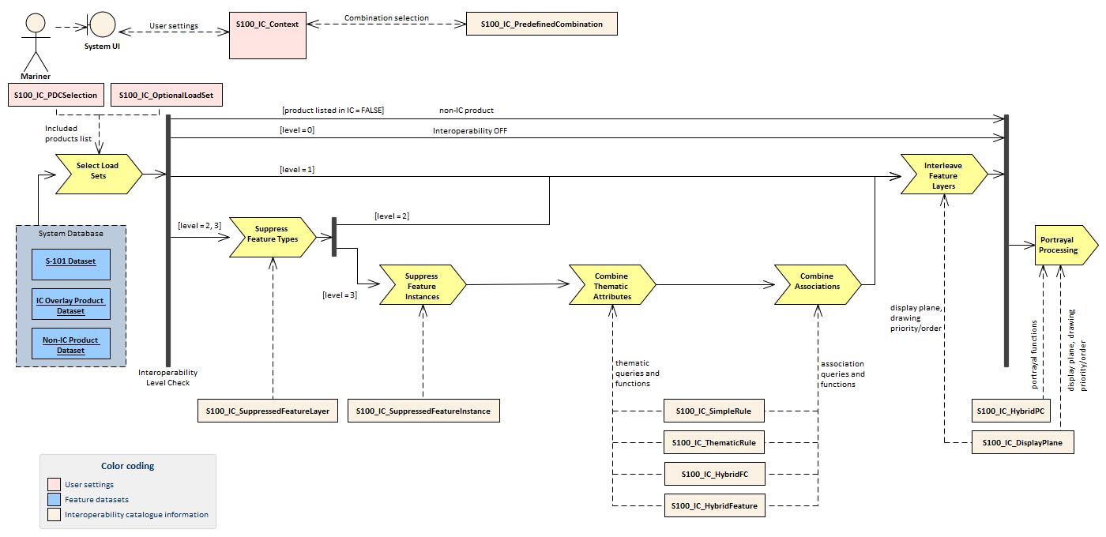

*Figure 7‑1 - Processing for Level 3 interoperability (interoperability precedes portrayal)*

The processing flow for the other implementation option (drawing instructions precede interoperability) is similar with an additional step (*Portrayal Processing*) moved to immediately follow loading of data.

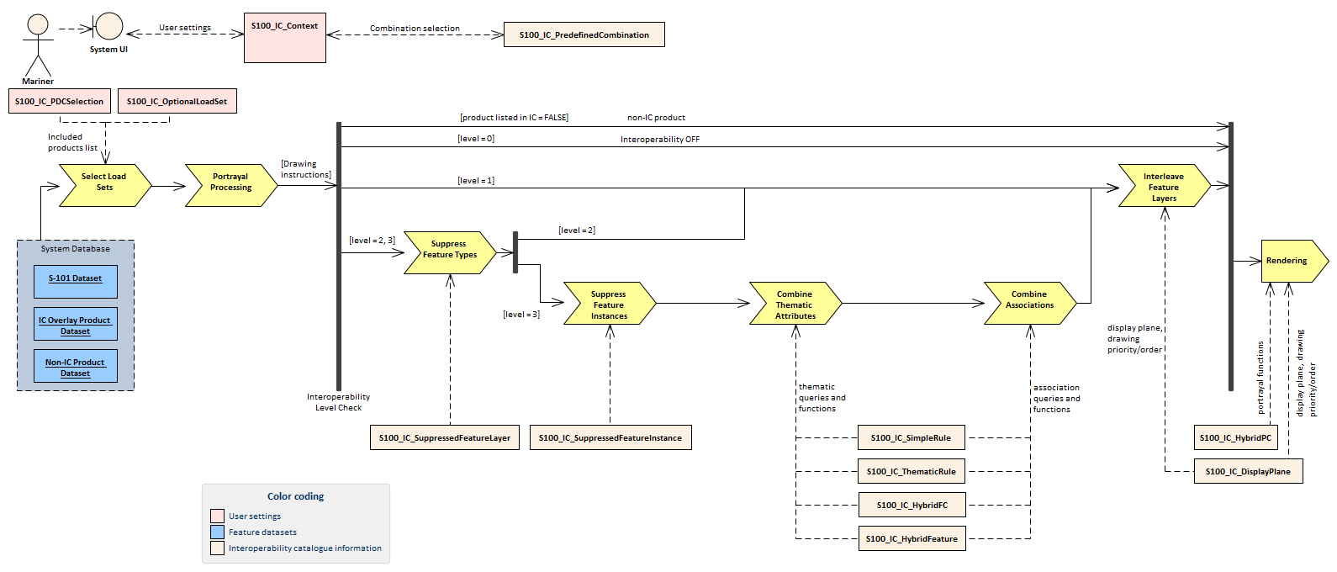

*Figure 7‑2 – Processing for Level 3 interoperability (Interoperability follows portrayal processing)*

*Table 7.2 - Stages in Level 3 interoperability processing*

| **Stage** | **Description** | **Level** | **IC information** | **Context information** | **Remarks** |
| --- | --- | --- | --- | --- | --- |
| Select Load Sets | Select data products to be loaded | All | Level 1: User adds data products to display individually  Level 2: Included product list from S100_IC_‌PredefinedCombination.‌includedProduct  Level 3: included product list from S100_IC_‌Predefined‌Combination.‌included‌Product | Level 1: None  Levels 2, 3: User-selected predefined combination. | Information & functionality depends on user-selected level setting. |
| Portrayal Processing | Ordinary S-100 portrayal processing | All | Levels 1,2: display planes  Level 3: Hybrid PC, display planes |  | Except final display processing / rendering |
| Interleave Feature Layers | Assign display plane and drawing order to feature data | 1, 2, 3 | S100_IC_DisplayPlane |  |  |
| Suppress Feature Types | Suppress all instances of a specified feature type in a product | 2,3 | S100_IC_Suppressed‌Feature‌Layer |  |  |
| Suppress Feature Instances | Suppress selected instances of a specified feature type in a product | 3 | S100_IC_Suppressed‌Feature‌Instance |  | Applies feature selector expressions encoded in *primarySelector* and *secondarySelector* attributes. |
| Combine Thematic Attributes | Select instances for hybridization and generate thematic attributes of a derived feature | 3 | S100_IC_SimpleRule, S100_IC_ThematicRule, S100_IC_HybridFeature, S100_IC_HybridFC |  |  |
| Combine Associations | Adjust associations | 3 | S100_IC_SimpleRule, S100_IC_ThematicRule, S100_IC_HybridFeature, S100_IC_HybridFC |  |  |
| Rendering | Display processing | All | S100_IC_DisplayPlane |  |  |

# Normative Implementation Guidance

There is no level-specific normative implementation guidance in this edition of S-98. See the Main component of this Specification for implementation guidance that applies to all levels.

# Feature Catalogue

Level 3 Interoperability Catalogues use a conditionally mandatory S-98 hybrid Feature Catalogue, which must be defined by Interoperability Catalogue developers if the Interoperability Catalogue contains hybridization rules which generate feature types which do not conform to the feature catalogue for one of the input data products.

# Portrayal Catalogue

Level 3 Interoperability Catalogues use a conditionally mandatory S-98 hybrid Portrayal Catalogue, which must be defined by Interoperability Catalogue developers if the Interoperability catalogue contains hybridization rules which generate feature types which do not conform to the feature catalogue for one of the input data products.

1. Attributes which describe the same characteristic of substantially the same phenomenon. These attributes will generally have the same name. Developers of interoperability catalogues can detect collisions by comparing application schemas and feature catalogues.
2. For the IC evaluation scope, a “dataset” is an entire interoperability catalogue file, an “element” is an interoperability catalogue component corresponding to one of the classes in the model depicted in S-100 Part 16 Figure 16-3.
3. “Resultant” means the result of applying interoperability operations to covered data. “Resultant feature” means the apparent feature as it appears on the display after application of interoperability. “Resultant dataset” means the collection of resultant features. A “modified resultant feature” is the feature or drawing instruction resulting from the application of an operation or rule which affects spatial or thematic attributes or their values, including combining or suppressing attributes or generating an instance of a feature defined in the HYBRID feature catalogue in Level 3 or 4. A “superseding feature” is a feature which suppresses a feature (instance or type) from another dataset, or whose priority is increased by an interoperability rule or operation (which would make it visible in preference to a feature which would otherwise overlie it). A “superseded feature” is one that is suppressed or overlaid by a superseding feature.